We asked several clubs and all age groups to submit some questions we could ask Colette Thomson MBE.
Here are the questions submitted. It was so hard to choose 7 so we decided to ask her them all.
Thank you to all who asked and an even bigger thanks to Colette for obliging and sending us this long with her photos .
1. From Sutton Town Intermediates. They chose 4.
Q. Who is your favourite player that you have ever coached?
A. I don’t really have a favourite. Players that listen try hard and make progress please me. I suppose having coached Beth Cobden since she was in Year 6 and seeing her with a Commonwealth Gold medal around her neck was evidence of the effect I can have on a player’s career.
Q. What did it feel like winning the Commonwealth Final in 2019?
A. Amazing!! I was very calm throughout knowing that we could win if we performed. I feel the last few seconds were a blur. It still feels a bit of a dream come true.
Q. Who would your dream team be from any nation and era?
A. GS Margaret Matenga – NZ 1980’s
GA. Sharelle McMahon. – Australia 2000’s
WA. Temepara George – NZ 2000’s
C. Laura Langman.- NZ 2005 - Current
WD Serena Guthrie – England – 2011 - Current
GD. Wai Taumanu – NZ 1980’s
GK Geva Mentor – England 2003 - Current
Q. Which player should we look out for in the future?
A. I think Amy Carter is an emerging talent. She is deceptively quick and has a good netball brain. She is currently juggling training to be a Doctor with netball but has already started to make an impact in the Senior International Arena. I see as long career ahead.
2. From Ian Fuller - Umpire National.
Q. Having played and coached at every recognised level, has the divide between the player's understanding of the umpire role changed over the years? How so?
A. Interesting question Ian!!! I think players are probably more aware of the rules but certainly question more now? Things like contact/contest is a big discussion for everyone. I also think both parties are more willing to talk about it now. Approaching an umpire was pretty unusual back in the “dark ages”
3. From Ortonets NC
Q. Does pressure feel different or the same from School club levels to Regional to National to win, with the very different audiences?
A. For me the pressure as a coach is pretty much the same. Can I make a difference when it matters? I find it difficult to forget a game when I don’t think I have coached well.
However, I do feel the public nature and recent expectation of the International Scene make decisions scrutinised far more, so I suppose this does add a bit more pressure.
4. From Marston Green Cougars
Q. How did you first start netball, what inspired you and how do you feel the dynamics of the game have changed over the years?
A. Started playing at school, but not till I was 12. Just enjoyed running around and took every opportunity to play. Never really knew England existed until I was selected for England Schools. Then just wanted to be the best I could.
The game is definitely more physical now. Players are stronger and allowed to contest for ball far more than in my days.
5. From BSNL [Summer League]
Q. If you could go back to your younger self what netball advice would you give yourself?
A. “ Enjoy every minute – work hard and always know you have given your all. The highs will be worth all the lows.

6. From Linden NC – they chose 3 questions.
Q. As a lifelong member of Linden NC what has been your proudest moment?
A. In life it has to be being awarded the MBE and receiving this from the Queen at Buckingham Palace
Internationally it has to be being instrumental in England winning the Commonwealth Games and the impact that that has had on Netball in England
For Linden it is probably winning the Wembley clubs tournament at our first attempt, as well as the seeing Linden players Beth Cobden, Layla Guscoth and Lauren Massey represent England at the World Youth Championships in 2013

Q. How do you manage juggling 9 Linden teams in the league?
A. Luckily, I only have to manage 5 as Dayl Dufrane does the other 4! I also have a great deal of help from Kemi Okunnu. It is a challenge and Saturday’s can be a very busy day. I enjoy the challenge of coaching the full range of players on a Wednesday evening an trying to ensure that everyone gets something out of the session. It is great to see players improving.
Q. What has been you most embarrassing moment during a match?
A Most embarrassing moment was as a coach down in Australia. After a time out I returned to the “bench” where the chairs were on a 2-foot platform. As I sat down on the chair I must have pushed it back because I toppled backwards off the platform and unceremoniously onto the floor. This was filmed by our performance analyst and played over and over again in team meetings.
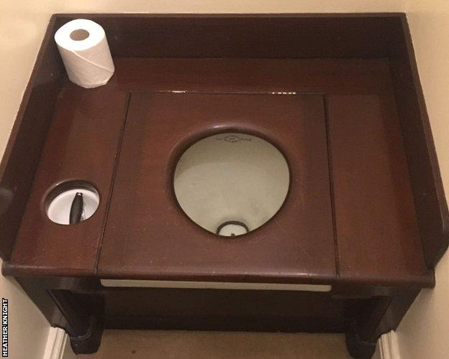
7. From Sharon [superfan] [girl fanning] [#collettesno1fan]
Q. You are an MBE WOW, this meant you went to the Palace. Was you tempted to take a memento apart from your medal? ha hahaha
- Took a picture of the loos!!!

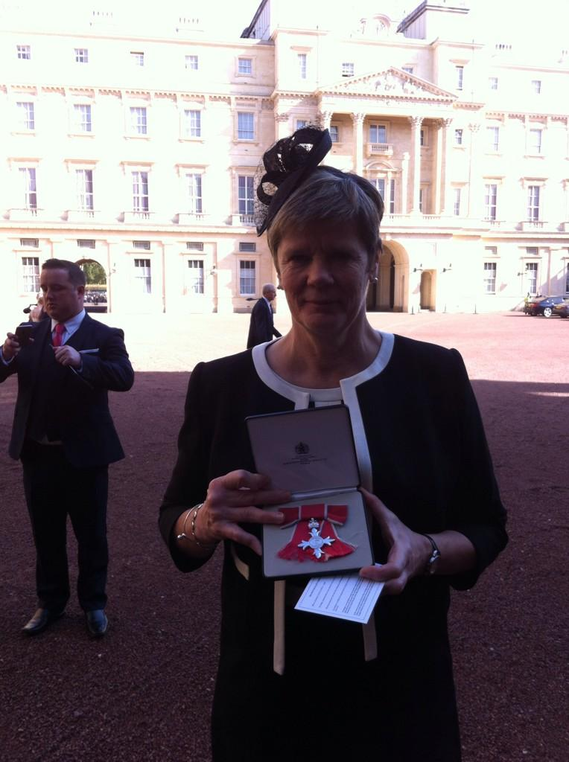
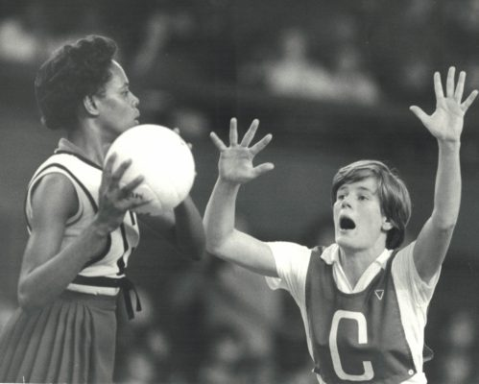
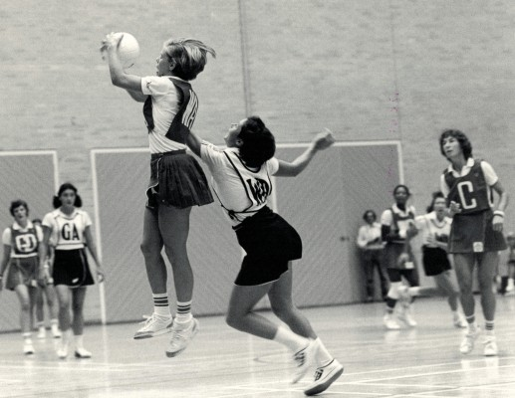
V New Zealand 1978 V Barbados 1980

