Central Netball League Constitution 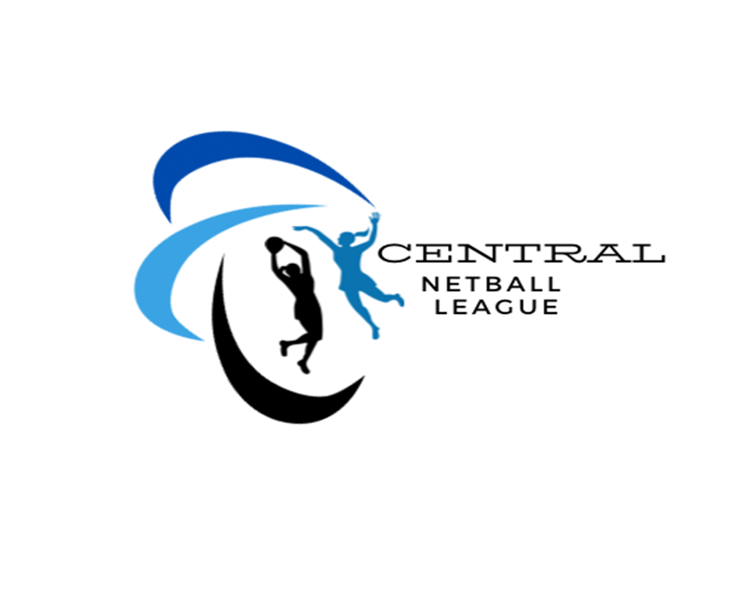

- The League shall be called Central Netball League [CNL]

- The League will be affiliated to the England Netball Association Ltd.

- Aims & Objectives

To promote the personal development for all League members, participants, volunteers and officials of the League in relation to netball and, where appropriate, provide routes to opportunities to enhance and increase individual skills.

The aims and objectives of the League shall be to:
- Promote netball and the League within Birmingham
- To offer competitive opportunities in netball
- To ensure a duty of care to all members of the League
- To provide all its services in a way that is fair to everyone
- Officers

  - The officers of the Club (known as the CNL Committee) shall be Chair, Vice-Chair, Secretary, Treasurer, Umpiring Secretary, League Safeguarding Officer, League Volunteer, Young person’s advocate, Co-ordinator and any other relevant position. They shall be affiliated to EN

  - These officers shall hold for a period of 3 years, being elected annually at the League Annual General Meeting (AGM). All Officers shall retire but shall be eligible for re-appointments.

  - Any casual vacancy occurring may be filled by the Committee.

  - The league will be managed through the Committee. The following posts will have the right to vote at meetings of the League Committee.
Vice-Chair
Treasurer
Secretary
Umpiring Secretary
League volunteer coordinators.

  - Meeting of the Committee shall be convened by the Secretary and the Committee shall meet no less than a 3 TIMES A YEAR (inc AGM). The Minutes of the Meetings will be taken by the Secretary.

  - The League Committee will be responsible for adopting new EN policy, codes of conduct and rules that affect the organisation of the League as voted at the AGM. No changes can be made by the Committee without League Club votes. Changes shall be notified at the AGM. In case of an immediate change required an EGM or League electronic voting shall take place

- Finance

  - All monies raised by or on behalf of the League shall be applied to further the objects of the League and for no other purpose.

  - All League monies will be banked in an account held in the name of the Central Netball League.

  - The Club Treasurer will be responsible for the finances of the League.

  - The financial year of the club will end on August 31st.

  - A statement of annual accounts will be presented by the Treasurer at the Annual General Meeting.

  - All payments will bare witness / approved by the treasury and 1 other committee member.

- Annual General Meeting and other Meetings

  - Notice of the Annual General Meeting (AGM) will be given by the League Secretary. Not less than 28 clear days’ notice to be given to all members.

  - The League will email out agenda to along with rules / constitution / code of conduct. If a club wants to make an amendment this can be made in writing to the secretary prior to the AGM for it to be voted at AGM. See 9.3 / 9.4

  - Elections of officers are to take place at the AGM.

- Voting Procedures

  - Each team shall be entitled to one vote.

  - A motion shall be carried by a single majority of those present and voting, this will include committee voting apart from CHAIR who will have decided vote if there is a tie.

- Dissolution Procedures

  - A resolution to dissolve the League can only be passed at an AGM through a majority vote of the membership.

  - In the event of dissolution, any assets of the League that remain will become the property of England Netball or some other club with similar objectives to those of the club. Any funds may be given to a Charity Organisation.
.
- Review of the Constitution / code of conduct / rules.

  - The above shall be reviewed on a yearly basis.

  - The above will only be changed through agreement by majority vote at an AGM.

  - Additions to, or alterations of the above shall be submitted to the Secretary not less than 21 days before the date of the AGM

  - In the event of a proposal for amending the above being submitted, the Secretary shall inform the membership of the proposed motion not less than 14 days before the AGM.

  - In the event of any question or matter arising, which is not provided in the constitution, shall be dealt with by the League Committee, whose decision shall be final.

Declaration
Central Netball League hereby adopts and accepts this constitution as a current operating guide regulating the actions of members.

SIGNED: DATE:

Name:
League Chair

SIGNED: DATE:

Name:
League Secretary

